THE KING´S PARADE
‘MARIO’
THE FEEL-GOOD LEAD SINGLE FROM THEIR DEBUT ALBUM
OUT NOW

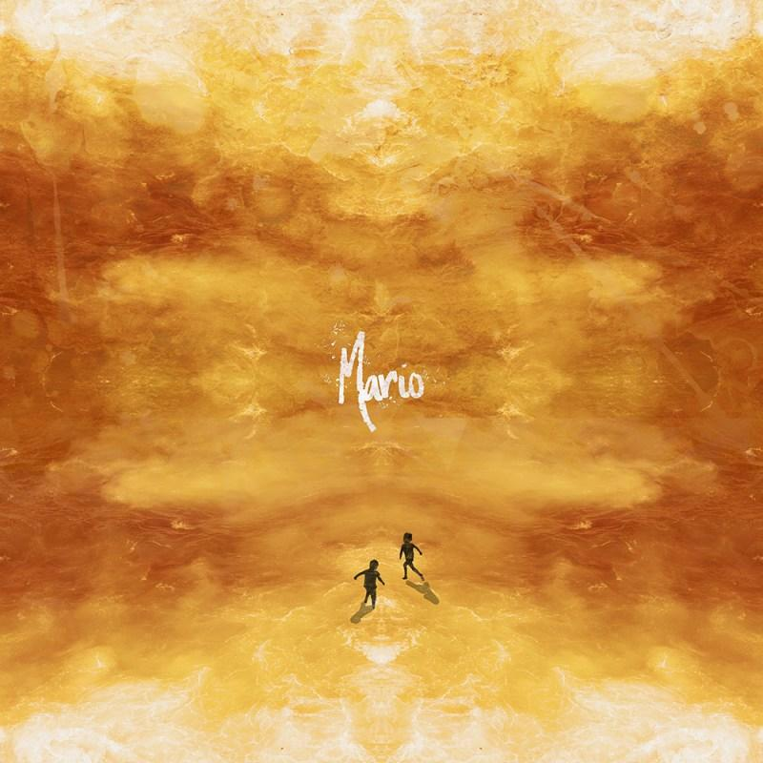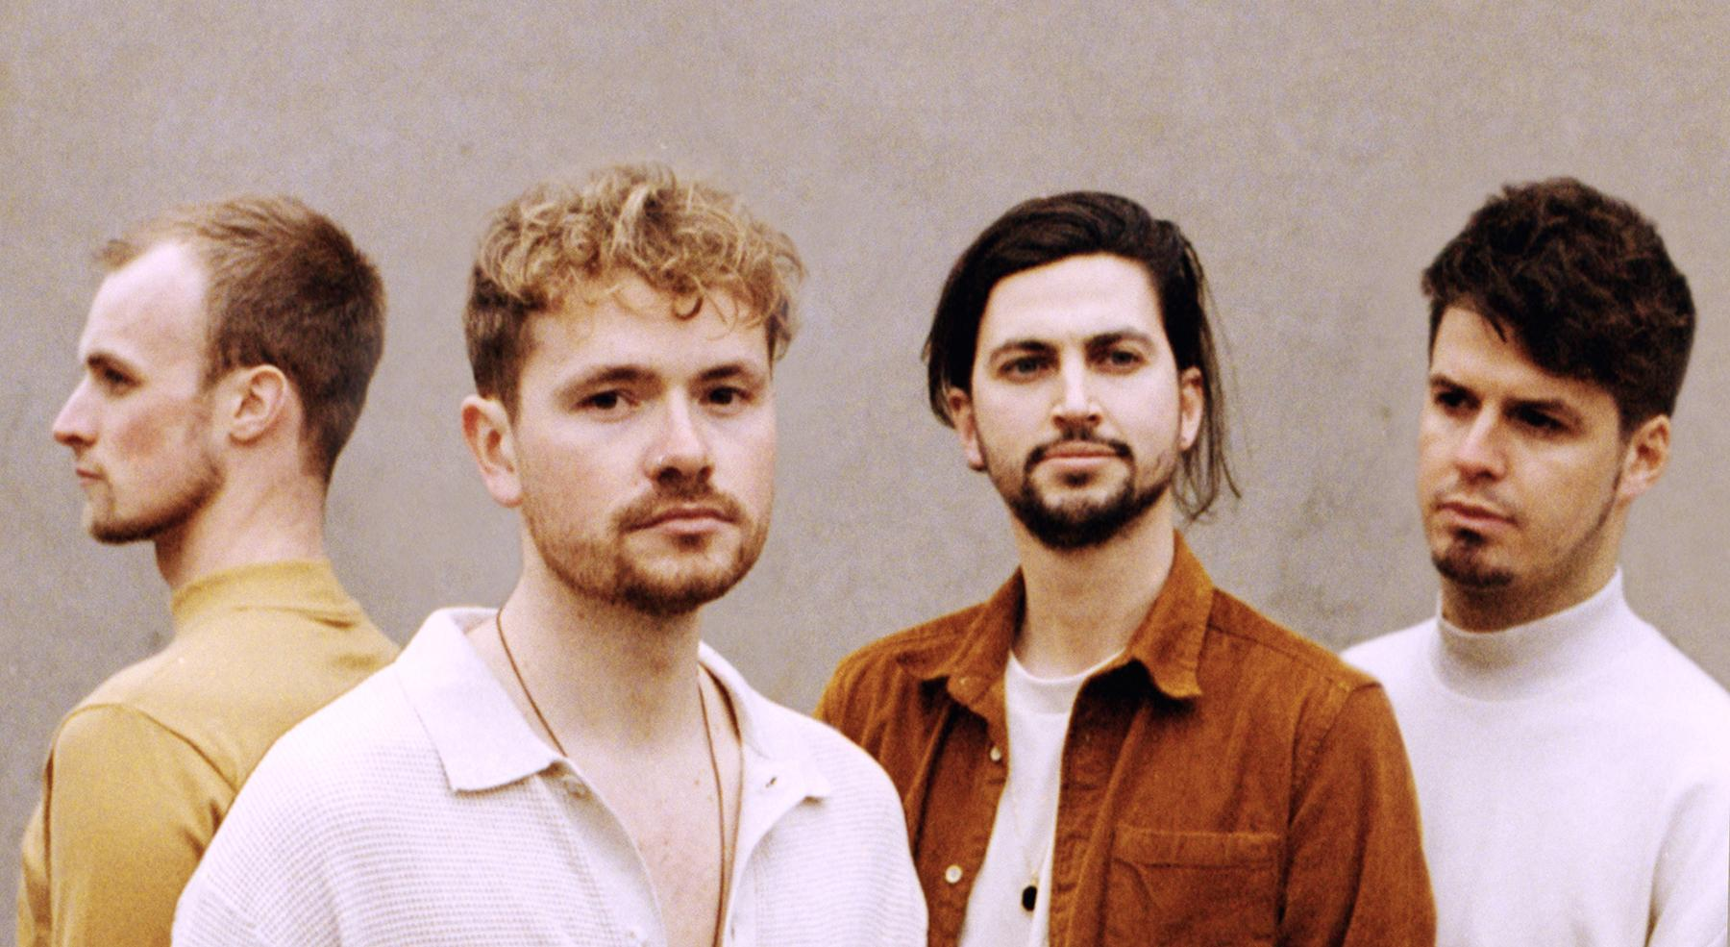

FOR RELEASE: FRIDAY 7 AUGUST 2020
LISTEN: Shortlink
IMAGE RESOURCES: Artwork / Promo
WATCH: Coming Soon

--- START ---

London based alt-soul outfit, The King's Parade return with ‘Mario’, the first of four singles taken from their upcoming debut album due in December.

Mario triggers a warm sense of nostalgia reminiscent of simpler times as it paints a picture of immortal moments shared between ´two kids on the run´ without a care in the world and, it seems, a blossoming love interest. A story to which many can relate. Sonically, the release marks a milestone in the band's career as proof they've really settled into the signature sound that´s gained them a loyal following over the years. Frontman and lead songwriter Olly Corpe explains:

“We have focussed on writing more feel-good tunes this time around, whilst making sure we stay true to who we are. To us, these are some of the most important songs we´ve ever written, as well as being some of the most accessible for new fans; it's a good mix. We´re really proud of this record and we promise Mario is a sure sign of what's to come.”

Recording for Mario started at the beginning of the year, along with the bulk of the upcoming album but was soon delayed due to the outbreak and ensuing global lockdown. The band used this time to engage with their fans more than ever before. Olly entertained us with live-streamed acoustic #StayAtHome sessions live from his living room every day, for eight weeks straight. The band hosted a TKP themed quiz (maximising their Zoom attendee allowances) which regularly featured other artists on their broadcasts, including chats with the likes of Billy Lockett and Hollie Carmen. They even released #StayAtHome merch featuring fan art of Olly´s live-stream backdrop (his lounge), which sold out... twice!

Amidst the newfound restrictions, like so many, the only viable option for the official Mario music video was to self-record and self-produce something entirely during lockdown - with the help of a few friends, of course. The aim was to produce a video that captured the imaginations of people around the world; to maintain a connection and keep spirits high.

The video recruited an army of fans from around the world, spanning Europe, New Zealand, USA, Mexico, Uganda and Cape Town. Bassist, Tom English tells us:

“We wanted to give people something fun to get involved with during lockdown. Each track on our upcoming album echoes a story of how we´re all connected, through friendship, through energy and through serendipity. We felt there no-better way to kick off the album releases with a dance that we hoped would spread across the world, and it has.”

This is the first time that The King´s Parade have ever featured in one of their own music videos without the safety net of an instrument. Drummer, Chris Brent notes:

“We´re not dancers, but we didn't want to let that stop us. If we were expecting our fans to share themselves dancing to our song on social media, then we knew we had to step up to the plate first. This is all about the bigger picture and trust me, nobody could be more awkward than us. It was supposed to be a boost to everyone else thinking ´well, I can´t be any worse than that´… and they really weren't. Everyone's done such an amazing job, and we´re so grateful to be able to feature so many people making the most of lockdown around the world”.

Mario is the first official release under new management and having secured private investment from a number of music industry professionals, this release paves a solid foundation for their biggest year yet as a proudly independent artist.

--- End ---

Boilerplate

Official Website: tkp.band
Band Bio: View Here
Facebook: https://www.facebook.com/thekingsparade
Instagram: https://www.instagram.com/thekingsparade
YouTube: https://www.youtube.com/thekingsparade
Twitter: https://www.twitter.com/thekingsparade
Vero: https://vero.com/thekingsparade

¨It's captivating alt-soul melding classic blues influence with a modern pop vibe¨
The Independent

¨Elegant guitar riffs and heartwarming vocals¨
Wonderland

¨The group are a sought-after creative force¨
Clash Magazine

¨This four man band are one of the most naturally talented groups out there¨
Earmilk

"An incredibly accomplished sound worthy of a far wider audience"
Tom Robinson

CONTACT
MGMT: simon@umamusic.com
PRESS: brooke@umamusic.co.uk

