THE KING’S PARADE RELEASE POWERFUL NEW SINGLE FROM UP-COMING DEBUT ALBUM
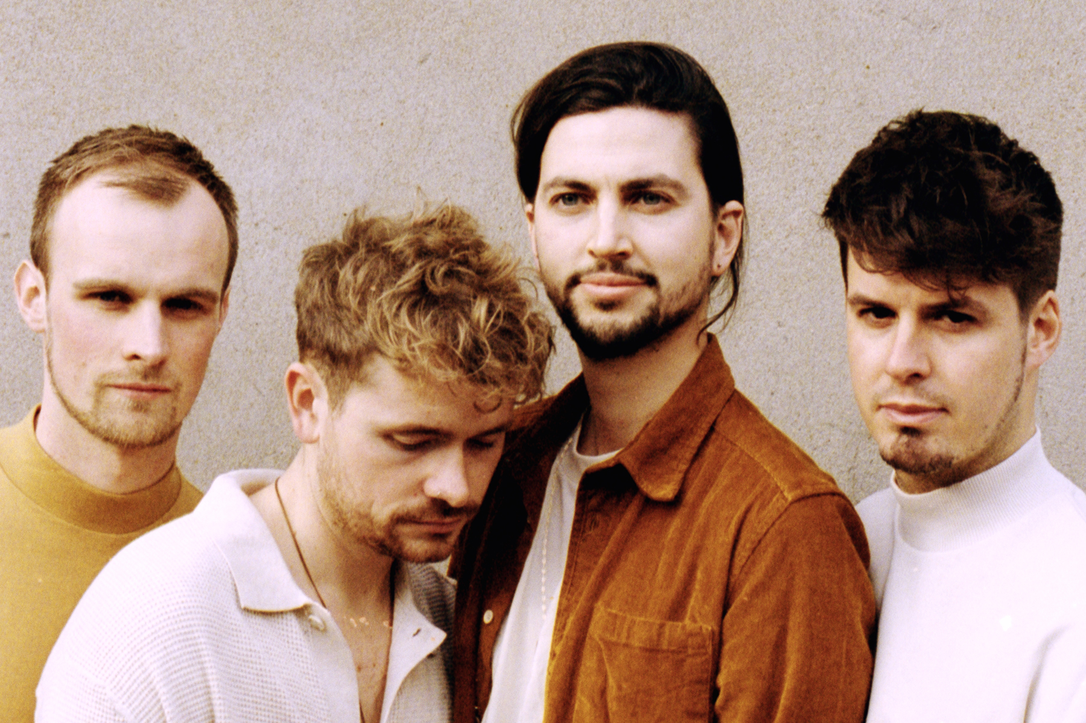
“Captivating alt-soul melding classic blues influence with a modern pop vibe” The Independent
“Elegant guitar riffs and heartwarming vocals” Wonderland
"The King’s Parade continue to win over the hearts of music lovers worldwide with their fun productions, great lyrics, and overall feel good vibe” Pop Wrapped
London based alt-pop outfit, The King’s Parade are set to return with their latest single ‘Little Rituals’ – out 19th February, it’s the seventh track to drop from their up-coming debut album, and follows their first six singles ‘Mario’, ‘How Long?’, 'Brother', 'Sister', ‘Wait’ and 'Alright For You'.
Early support for the band’s most recent singles has come from The Independent, who featured ‘How Long?’ in their ‘Now Hear This’ column, calling the track the band’s ‘best song to date’, and Spotify, who added the band’s last single (‘Wait’) to their official ‘New Music Friday UK’ and ‘Lost In The Woods’ playlists.
'Little Rituals' draws on an intriguing mix of the band's alt-indie influences; imagine the sonic textures in Radiohead's 'In Rainbows' album combined with the impassioned vocals of indie artists like Sam Fender and Half Moon Run and you're getting close. Soaring above a relentless, pulsating rhythm section, frontman Olly Corpe's emotionally charged vocals explore themes of addiction and destiny, reflecting on how the two things relate to each other.
Speaking about the track he explains that:
“Life sometimes feels like a series of pre-determined building blocks. The song is about breaking the routine and questioning destiny. How much control do we have over our own paths, addictions and desires? And can we break away from ourselves or will that battle to break away ultimately be another piece of a pre-determined puzzle?"
An official music video is on the way, meanwhile their previous video for ‘Mario’ has gained 150K views so far and has been lauded for its creativity, as the band like so many others, had to create something self-produced during lockdown. With the help of friends and fans from across the globe (spanning Europe, New Zealand, USA, Mexico, Uganda and South Africa), they created something totally joyous and celebratory, fitting for these strange times - watch the official music video for Mario here.
Having established a loyal live fanbase and streams in the 10s of millions across all platforms online (through a series of hugely successful tours, singles and EPs), news of their debut album is much overdue and highly anticipated. The album, out in May 2021 was recorded by Marco Pasquariello (credits include Coldplay and Snow Patrol) and produced by GRAMMY award winning producer Guy Massey (credits include Ed Sheeran, Jack Savoretti and The Libertines).
Prior to this, 2019 saw the release of their most recent EP ‘Mad’ which was backed by a sold-out headline European tour across Spain, Italy, France, Germany and the UK. The EP rallied strong tastemaker support from the likes of BBC 6Music, The Independent, Clash, Earmilk and many more. This year, the band utilised lockdown to engage with their fans more than ever before. Olly streamed acoustic #StayAtHome sessions live from his living room every day, for eight weeks straight and they all hosted a The King’s Parade themed quiz on Zoom which featured other artists, including Billy Lockett and Hollie Carmen. They even released #StayAtHome merch featuring fan art of Olly´s live-stream backdrop (his lounge), which sold out… twice!

