THE KING’S PARADE TO RELEASE LATEST SINGLE FROM UP-COMING DEBUT ALBUM

THE KING’S PARADE – BROTHER (OUT VIA AWAL ON 2ND OCTOBER 2020) – PREVIEW:
https://soundcloud.com/thekingsparade/brother/s-VRNvp4FIeaU

Press pack: https://drive.google.com/drive/folders/1X94kmKNH12LmfQ9MsRL2wdlS6Px3TH5n?usp=sharing

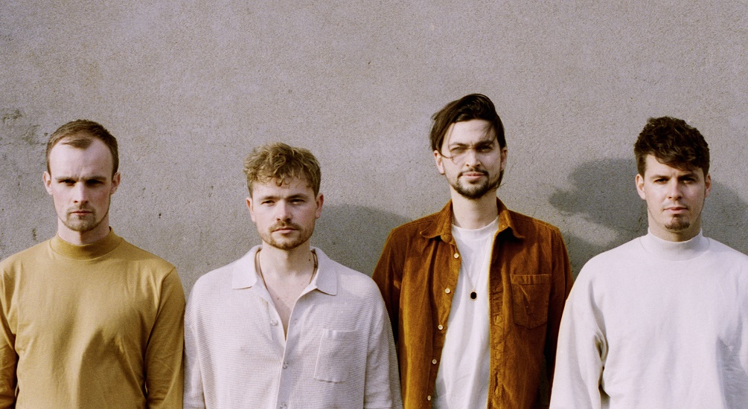

“Captivating alt-soul melding classic blues influence with a modern pop vibe”
The Independent

“Elegant guitar riffs and heartwarming vocals” Wonderland

London based alt-pop outfit, The King’s Parade are set to return with their latest single ‘Brother’ – out 2nd October, it’s the third track to drop from their up-coming debut album, and follows their first two singles ‘Mario’ and ‘How Long?’.
Early support for the band’s most recent singles has come from Tom Robinson at BBC 6 Music, who described them as having “an incredibly accomplished sound worthy of a far wider audience” and The Independent, who featured ‘How Long?’ in their ‘Now Hear This’ column, calling the track the band’s ‘best song to date’.
‘Brother’ is yet another single that represents a band at the peak of its powers. The song leads with an ethereal, wandering guitar riff before the band erupts and frontman Olly Corpe breaks into an effortlessly smooth croon, evoking feelings of vulnerability that blend seamlessly with the song’s lyrics. Bolstered by a punchy, infectious groove and catchy melodies, The King’s Parade reaffirm their ability to combine delicate lyrical themes with a powerful and gritty delivery, calling to mind the sounds of Alabama Shakes, The Black Keys and Leon Bridges.
Frontman Olly Corpe explains the inspiration behind the track:
“‘Brother’ is a track about feeling left behind. The sudden disappearance of someone you hold close to your heart can leave an emptiness that feels impossible to fill. The song is an expression of that void.”
An official music video for ‘Brother’ is on the way, meanwhile their previous video for ‘Mario’ has gained 150K views so far and has been lauded for its creativity, as the band like so many others, had to create something self-produced during lockdown. With the help of friends and fans from across the globe (spanning Europe, New Zealand, USA, Mexico, Uganda and South Africa), they created something totally joyous and celebratory, fitting for these strange times.
Having established a loyal live fanbase and streams in the 10s of millions across all platforms online (through a series of hugely successful tours, singles and EPs), news of their debut album is much overdue and highly anticipated. The album, out in December 2020 was recorded by Marco Pasquariello (credits include Coldplay and Snow Patrol) and was produced by Guy Massey (credits include Ed Sheeran, Jack Savoretti and The Libertines).
Prior to this, 2019 saw the release of their most recent EP ‘Mad’ which was backed by a sold-out headline European tour across Spain, Italy, France, Germany and the UK. The EP rallied strong tastemaker support from the likes of BBC 6Music, The Independent, Clash, Earmilk and many more. This year, the band utilised lockdown to engage with their fans more than ever before. Olly streamed acoustic #StayAtHome sessions live from his living room every day, for eight weeks straight and they all hosted a The King’s Parade themed quiz on Zoom which featured other artists, including Billy Lockett and Hollie Carmen. They even released #StayAtHome merch featuring fan art of Olly´s live-stream backdrop (his lounge), which sold out… twice!

‘Brother’ is out on all digital platforms 2nd October 2020, with an official music video to follow

Follow The King’s Parade: Web | Facebook | Instagram | YouTube | Twitter | Spotify

Press contact: chrisbrent@thekingsparade.com | Management contact: simon@umamusic.com

